**Subjective Questions**

1. Which are the top three variables in your model which contribute most towards the probability of a lead getting converted?

Answer : These are the top three variables which contribute most towards the probability of a lead getting converted

* From Lead Origin- Lead Add Form
* From Lead Source- Welingak Website
* From Lead Source- Olark Chat

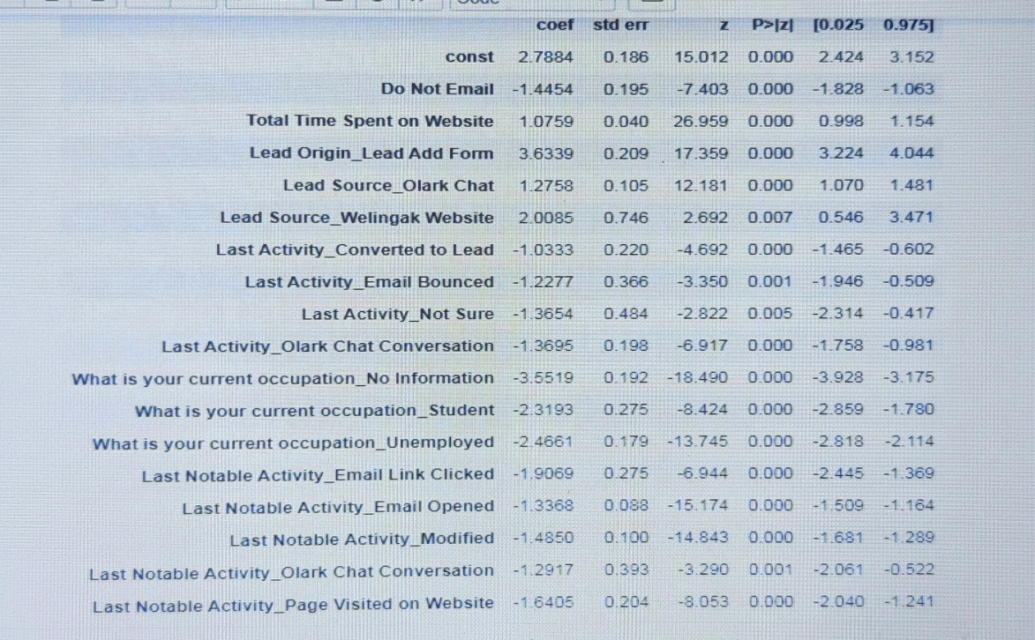

1. What are the top 3 categorical/dummy variables in the model which should be focused the most on in order to increase the probability of lead conversion?

Answer : These are the top 3 categorical/dummy variables in the model which should be focused the most on in order to increase the probability of lead conversion

* From Lead Origin- Lead Add Form
* From Lead Source- Welingak Website
* From Lead Source- Olark Chat

1. X Education has a period of 2 months every year during which they hire some interns. The sales team, in particular, has around 10 interns allotted to them. So during this phase, they wish to make the lead conversion more aggressive. So they want almost all of the potential leads (i.e. the customers who have been predicted as 1 by the model) to be converted and hence, want to make phone calls to as much of such people as possible. Suggest a good strategy they should employ at this stage.

Answer: In order to make the sales aggressive, the company may contact all the leads which have a conversion probability (value = 1) under a cut off 0.3.

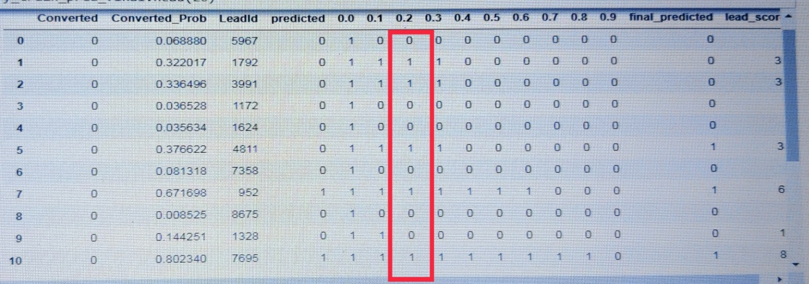

Also phone calls can be done to people if they spend

* If they spend lot of time in browsing website, this can be achieved by making website interesting.
* If the customers are visiting the website repeatedly.
* If they are working professionals.

1. Similarly, at times, the company reaches its target for a quarter before the deadline. During this time, the company wants the sales team to focus on some new work as well. So during this time, the company’s aim is to not make phone calls unless it’s extremely necessary, i.e. they want to minimize the rate of useless phone calls. Suggest a strategy they should employ at this stage.

Answer: In this condition company should resort to automated SMS and Email, this way calling wont be required unless it is emergency or the company may contact all the leads which have a conversion probability (value = 1 marked in red color box) under column 0.6.

